**PROJECT REPORT**

**Bankruptcy Prediction**

*Submitted towards the partial fulfillment of the criteria for award of PGA by Imarticus*

*Submitted By:*

*V.MURALIDHARAN (Roll Number: IL029208)*

*Course and Batch: PGA 20 – Feb2022*



# Abstract

Prediction of bankruptcy is a phenomenon of increasing interest to firms who stand to lose money when organization is unable to honour its financial obligations it files for bankruptcy. This becomes the major concern for every company for its past years. This data helps to perform research and analysis on the data for better prediction.

In this project, I created a model that will predict whether the company will go bankrupt or not. With the help of this model we can solve some business challenges pertaining to bankruptcy like to reduce the liabilities and debts of the company by analysing and predicting with several classification algorithms.

# Acknowledgements

I am using this opportunity to express my gratitude to everyone who supported me throughout the course of this project. I’m thankful for their aspiring guidance, invaluably constructive criticism and friendly advice during the project work. I am sincerely grateful to them for sharing their truthful and illuminating views on a number of issues related to the project.

Further, we were fortunate to have great teachers as our mentor. He/She has readily shared their immense knowledge in data analytics and guide us in a manner that the outcome resulted in enhancing our data skills.

I wish to thank, all the faculties, as this project utilized knowledge gained from every course that formed the PGA program.

I certify that the work done by us for conceptualizing and completing this project is original and authentic.

Date:

Place: Chennai Muralidharan V

# Certificate of Completion

I hereby certify that the project titled “Bankruptcy Prediction” was undertaken and completed under my supervision by Muralidharan V from the batch of PGA20 (Feb 2022)

Mentor:

Date:

Place –Chennai

Table of Contents

[Abstract 2](#_Toc99178499)

[Acknowledgements 3](#_Toc99178500)

[Certificate of Completion 4](#_Toc99178501)

[CHAPTER 1: INTRODUCTION 6](#_Toc99178502)

[1.1 Title & Objective of the study 6](#_Toc99178503)

[1.2 Need of the Study 6](#_Toc99178504)

[1.3 Data Description 6](#_Toc99178506)

[1.4 Data Sources 6](#_Toc99178507)

[1.5 Tools & Techniques 6](#_Toc99178508)

[CHAPTER 2: DATA EXPLORATION AND ANALYSIS 6](#_Toc99178510)

[2.1 Data View 6](#_Toc99178511)

[2.2 Data Analysis 6](#_Toc99178512)

[2.3 Feature Analysis 7](#_Toc99178513)

[2.4 Feature Engineering 7](#_Toc99178514)

[CHAPTER 3: MODEL BUILDING WITH DATA 17](#_Toc99178515)

[3.1 Logistic Regression model 7](#_Toc99178518)

[3.2 Random Forest model 7](#_Toc99178519)

[CHAPTER 4: HYPERPARAMETER TUNING AND RFE 8](#_Toc99178522)

[CHAPTER 5: CONCLUSION 9](#_Toc99178523)

[CHAPTER 6: DEPLOYMENT OF THE MODEL 9](#_Toc99178523)

[CHAPTER 7: REFERENCES 9](#_Toc99178524)

# CHAPTER 1: INTRODUCTION

## Title & Objective of the study

This dataset gives the information about the bankrupt details of a Taiwan based company form year 1999 to 2009 and the details was collected from Taiwan economic journal. This dataset provides inventory of the company’s banking details.

The main objective is to predict whether the company will go bankrupt or not. I have used few Supervised Machine Learning classification algorithms and performance improved techniques to create a predictive modeling which can be used in relation to my objective.

## Need of the Study

Bankruptcy Prediction has become one of the principal and foremost concern of the firms who stand to lose money when organization is unable to honour its financial obligations. If we are able to figure out why the company is likely to go bankrupt it would immensely help the organization to make future decisions accordingly to avoid the bankruptcy of the company.

## Data Description

Y - Bankrupt Class label

X1 - ROA(C) before interest and depreciation before interest: Return On Total Assets(C)

X2 - ROA(A) before interest and % after tax: Return On Total Assets(A)

X3 - ROA(B) before interest and depreciation after tax: Return On Total Assets(B)

X4 - Operating Gross Margin: Gross Profit/Net Sales

X5 - Realized Sales Gross Margin: Realized Gross Profit/Net Sales

X6 - Operating Profit Rate: Operating Income/Net Sales

X7 - Pre-tax net Interest Rate: Pre-Tax Income/Net Sales

X8 - After-tax net Interest Rate: Net Income/Net Sales

X9 - Non-industry income and expenditure/revenue: Net Non-operating Income Ratio

X10 - Continuous interest rate (after tax): Net Income-Exclude Disposal Gain or Loss/Net Sales

X11 - Operating Expense Rate: Operating Expenses/Net Sales

X12 - Research and development expense rate: (Research and Development Expenses)/Net Sales

X13 - Cash flow rate: Cash Flow from Operating/Current Liabilities

X14 - Interest-bearing debt interest rate: Interest-bearing Debt/Equity

X15 - Tax rate (A): Effective Tax Rate

X16 - Net Value Per Share (B): Book Value Per Share(B)

X17 - Net Value Per Share (A): Book Value Per Share(A)

X18 - Net Value Per Share (C): Book Value Per Share(C)

X19 - Persistent EPS in the Last Four Seasons: EPS-Net Income

X20 - Cash Flow Per Share

X21 - Revenue Per Share (Yuan ¥): Sales Per Share

X22 - Operating Profit Per Share (Yuan ¥): Operating Income Per Share

X23 - Per Share Net profit before tax (Yuan ¥): Pretax Income Per Share

X24 - Realized Sales Gross Profit Growth Rate

X25 - Operating Profit Growth Rate: Operating Income Growth

X26 - After-tax Net Profit Growth Rate: Net Income Growth

X27 - Regular Net Profit Growth Rate: Continuing Operating Income after Tax Growth

X28 - Continuous Net Profit Growth Rate: Net Income-Excluding Disposal Gain or Loss Growth

X29 - Total Asset Growth Rate: Total Asset Growth

X30 - Net Value Growth Rate: Total Equity Growth

X31 - Total Asset Return Growth Rate Ratio: Return on Total Asset Growth

X32 - Cash Reinvestment %: Cash Reinvestment Ratio

X33 - Current Ratio

X34 - Quick Ratio: Acid Test

X35 - Interest Expense Ratio: Interest Expenses/Total Revenue

X36 - Total debt/Total net worth: Total Liability/Equity Ratio

X37 - Debt ratio %: Liability/Total Assets

X38 - Net worth/Assets: Equity/Total Assets

X39 - Long-term fund suitability ratio (A): (Long-term Liability+Equity)/Fixed Assets

X40 - Borrowing dependency: Cost of Interest-bearing Debt

X41 - Contingent liabilities/Net worth: Contingent Liability/Equity

X42 - Operating profit/Paid-in capital: Operating Income/Capital

X43 - Net profit before tax/Paid-in capital: Pretax Income/Capital

X44 - Inventory and accounts receivable/Net value: (Inventory+Accounts Receivables)/Equity

X45 - Total Asset Turnover

X46 - Accounts Receivable Turnover

X47 - Average Collection Days: Days Receivable Outstanding

X48 - Inventory Turnover Rate (times)

X49 - Fixed Assets Turnover Frequency

X50 - Net Worth Turnover Rate (times): Equity Turnover

X51 - Revenue per person: Sales Per Employee

X52 - Operating profit per person: Operation Income Per Employee

X53 - Allocation rate per person: Fixed Assets Per Employee

X54 - Working Capital to Total Assets

X55 - Quick Assets/Total Assets

X56 - Current Assets/Total Assets

X57 - Cash/Total Assets

X58 - Quick Assets/Current Liability

X59 - Cash/Current Liability

X60 - Current Liability to Assets

X61 - Operating Funds to Liability

X62 - Inventory/Working Capital

X63 - Inventory/Current Liability

X64 - Current Liabilities/Liability

X65 - Working Capital/Equity

X66 - Current Liabilities/Equity

X67 - Long-term Liability to Current Assets

X68 - Retained Earnings to Total Assets

X69 - Total income/Total expense

X70 - Total expense/Assets

X71 - Current Asset Turnover Rate: Current Assets to Sales

X72 - Quick Asset Turnover Rate: Quick Assets to Sales

X73 - Working capital Turnover Rate: Working Capital to Sales

X74 - Cash Turnover Rate: Cash to Sales

X75 - Cash Flow to Sales

X76 - Fixed Assets to Assets

X77 - Current Liability to Liability

X78 - Current Liability to Equity

X79 - Equity to Long-term Liability

X80 - Cash Flow to Total Assets

X81 - Cash Flow to Liability

X82 - CFO to Assets

X83 - Cash Flow to Equity

X84 - Current Liability to Current Assets

X85 - Liability-Assets Flag: 1 if Total Liability exceeds Total Assets, 0 otherwise

X86 - Net Income to Total Assets

X87 - Total assets to GNP price

X88 - No-credit Interval

X89 - Gross Profit to Sales

X90 - Net Income to Stockholder's Equity

X91 - Liability to Equity

X92 - Degree of Financial Leverage (DFL)

X93 - Interest Coverage Ratio (Interest expense to EBIT)

X94 - Net Income Flag: 1 if Net Income is Negative for the last two years, 0 otherwise

X95 - Equity to Liability

## Data Sources

<https://www.kaggle.com/fedesoriano/company-bankruptcy-prediction>

(Source: Kaggle.com)

## Tools & Techniques

* Python Libraries : Numpy, pandas,scikit learn
* Data Visualization : Matplotlib,seaborn
* Tool used : Jupyter notebook,VS Code
* Techniques : SMOTE

# CHAPTER 2: DATA EXPLORATION AND ANALYSIS

One of the first steps I engaged in was to outline the sequence of steps that we will be following for our project. Each of these steps are elaborated below

## 2.1 Data View

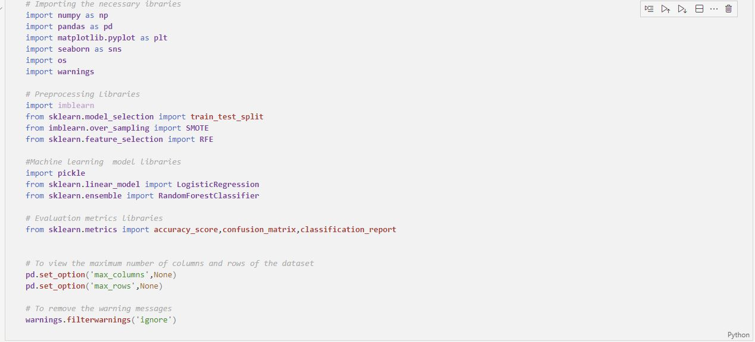

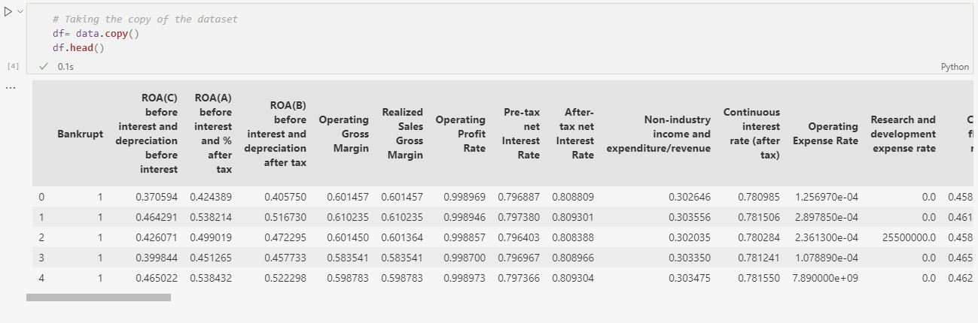

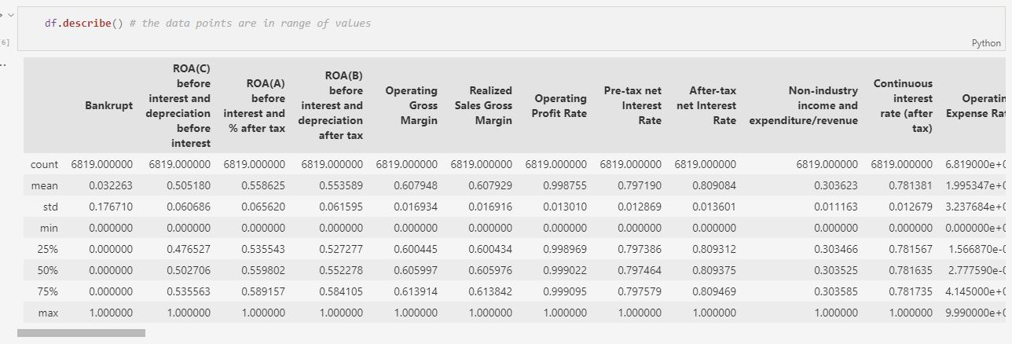

## 2.2 Data Analysis

* **Data dimension and information**

**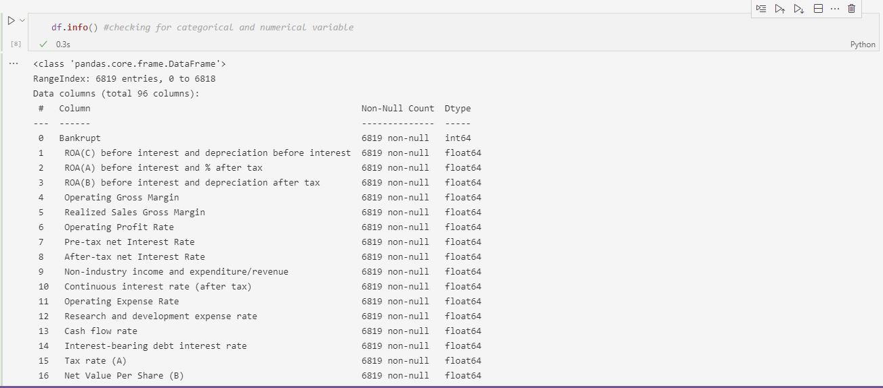**

**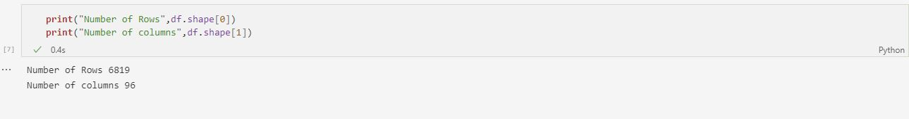**

* **Missing Value Analysis and Treatment**

There are no missing values in the dataset.

**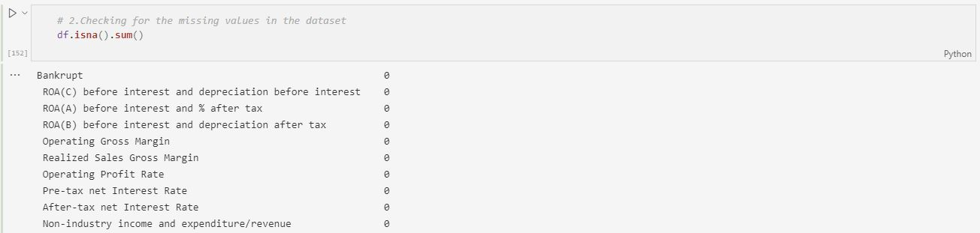**

There are no duplicate values in the dataset.

**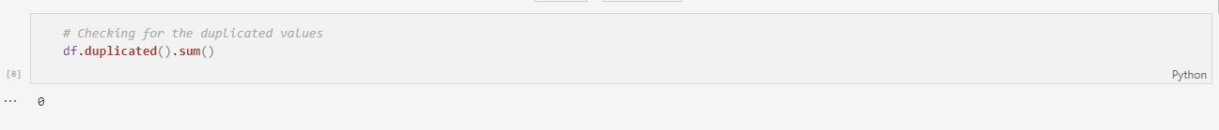**

* **Handling Outliers**

Since the values are scaled and mostly in range to check the outliers Z-Score method is used.

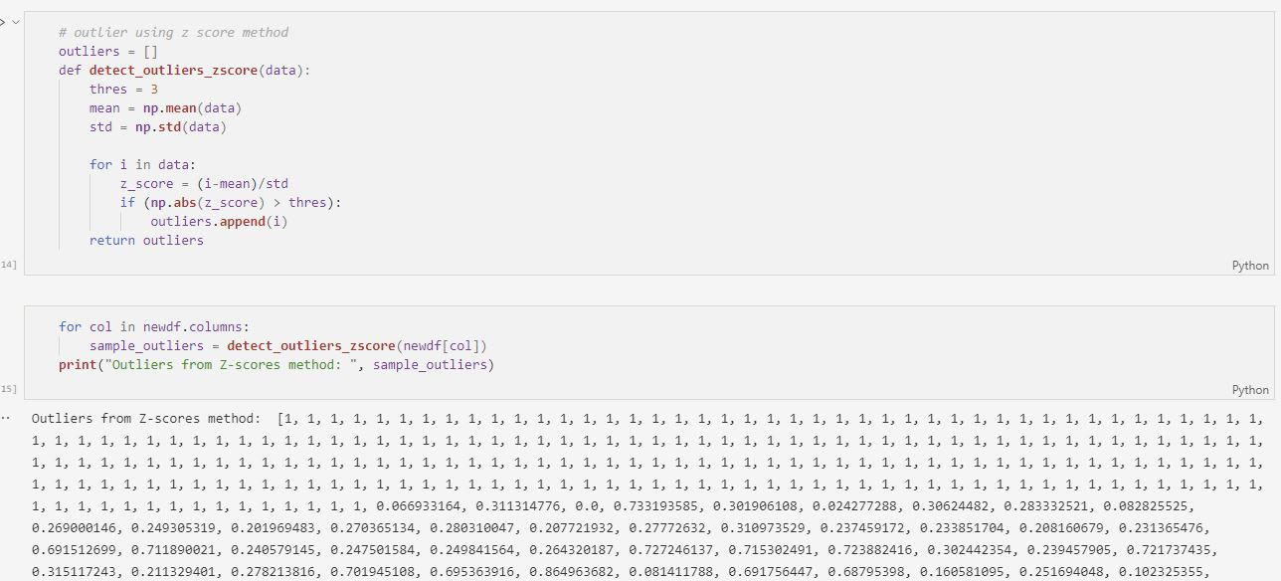

Finding the columns whichever is having outlier

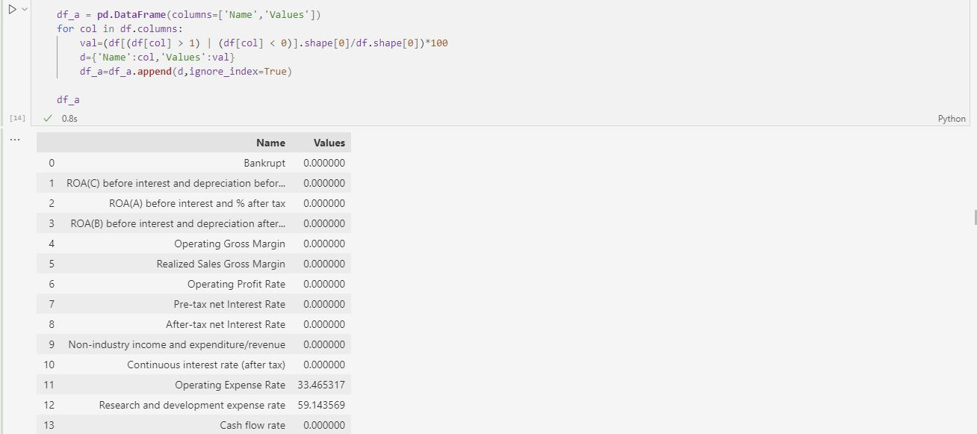

Treating the outlier by median method since it is numerical variables.

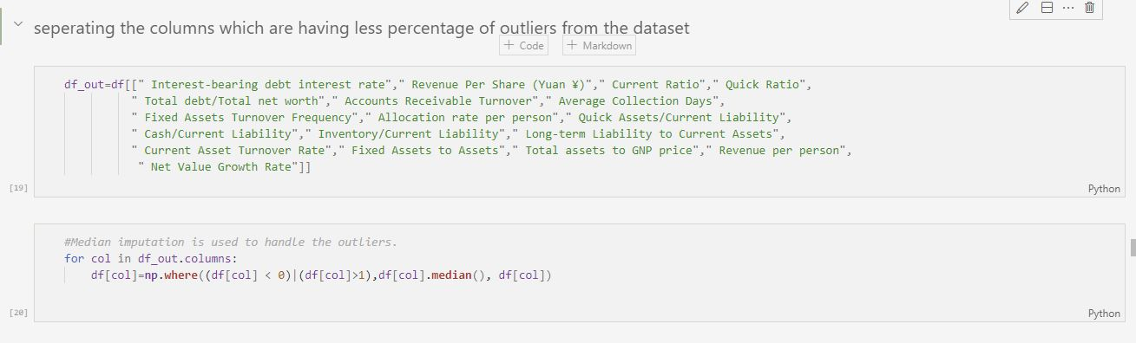

## 2.3 Feature Analysis

Dependent variable analysis

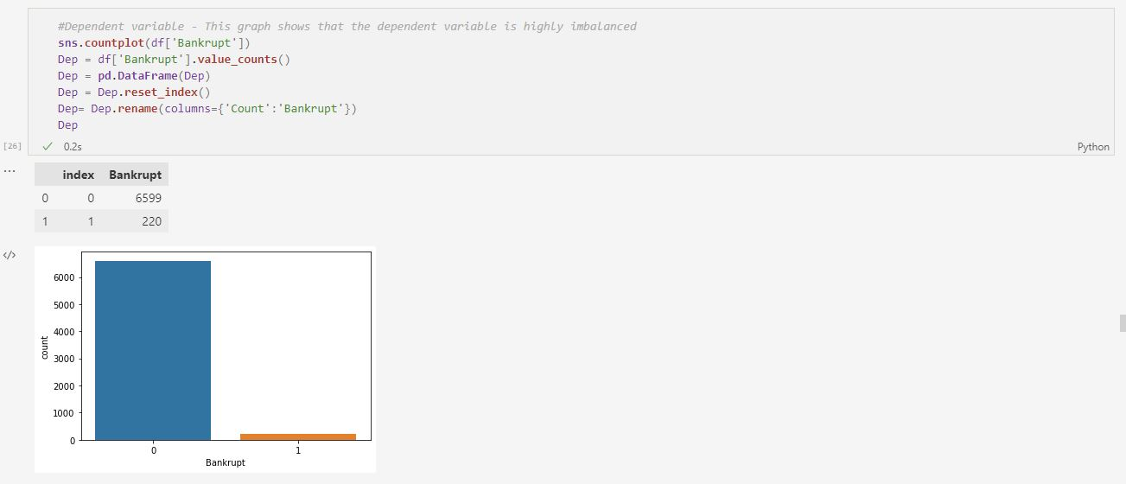

Analysis on other variables comparing with the dependent variable

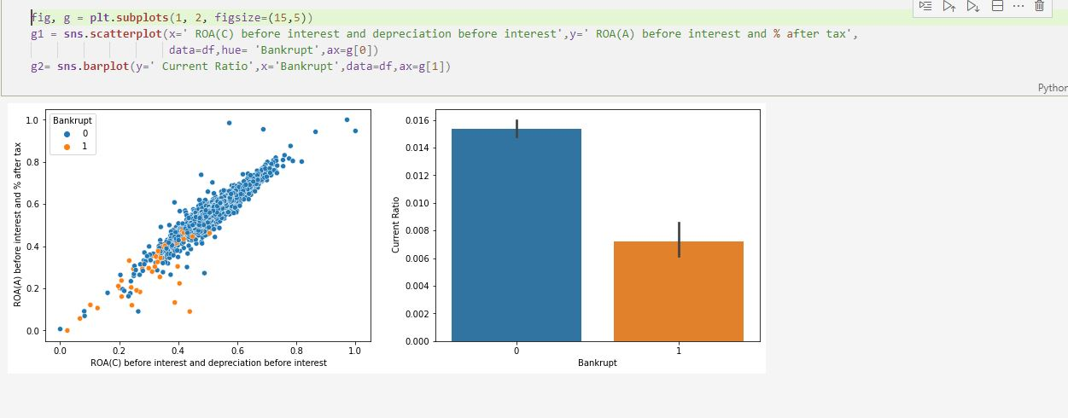

Inference:

G1. Return on total asset (ROA) (C) & (A) provides us the information that lower the returns most likely the company might go bankrupt.

G2. Current ratio is company’s short term liquidity to pay off all debts so it majorly influences whether company will go bankrupt.

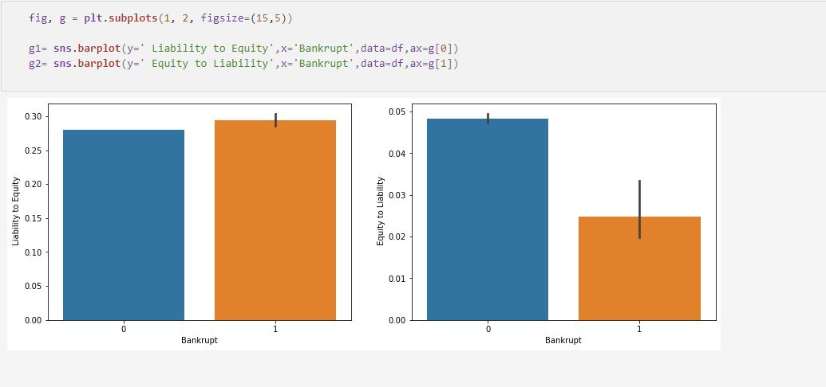

Inference:

G1.Liability to equity is company's total liabilities to its stakeholder's equity which has high influence of the company to go bankrupt

G2.Equity to Liability is that the company’s total debt to total equity which has influence on whether company might go bankrupt

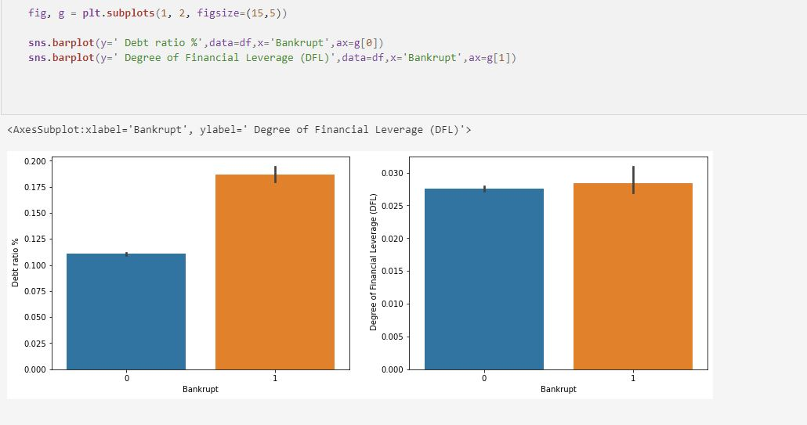

Inference:

G1. If the debt ratio of the company is more higher more likely the company will go bankrupt

G2. If DFL is high then more possibility that company may go bankrupt

## C:\Users\HP\Pictures\Project images\EDA_4.JPG

Inference:

G1. If the Return on Assets(ROA) is low then the company might go bankrupt means it has to sell its assets.

G2. Quick ratio is that the capabilities of the company to pay its current liabilities without selling the company so , if the quick ratio is lower the company will go bankrupt

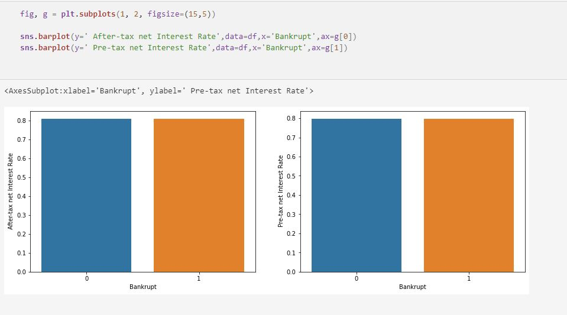

Inference:

G1. Return on investment that include tax has major importance on the company whether it might go bankrupt or not

G2. Return on investment that does not include tax has equal importance on the company whether it might go bankrupt or not

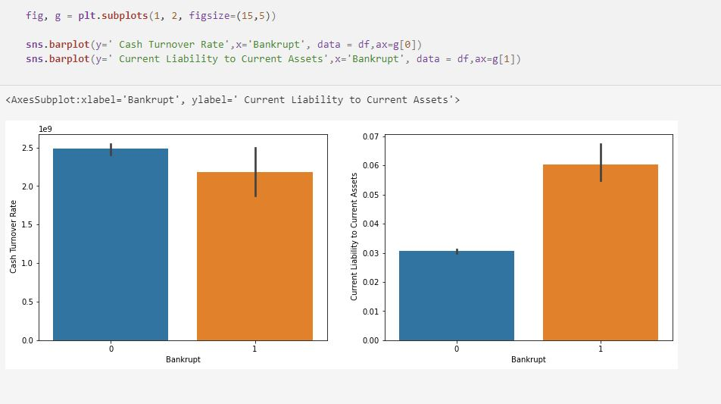

Inference:

G1. The cash turnover rate highly influences the bankruptcy prediction of the company.

G2. Current liability to current assets also influences majorly for bankruptcy, so we need to reduce it.

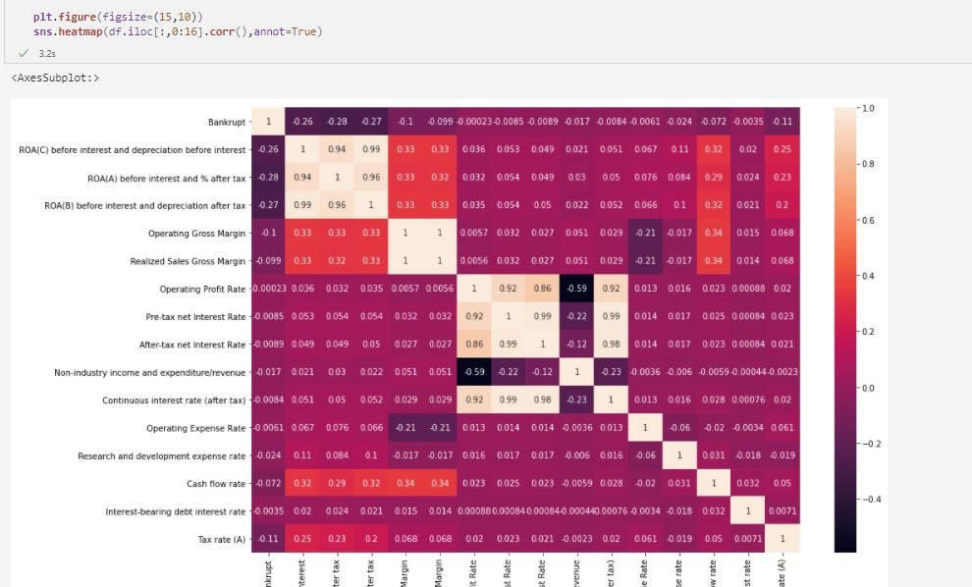

Inference:

The correlation matrix shows that the features are highly correlated so we can drop one of the features, Such as ROB(B) before interest and depreciation after tax.

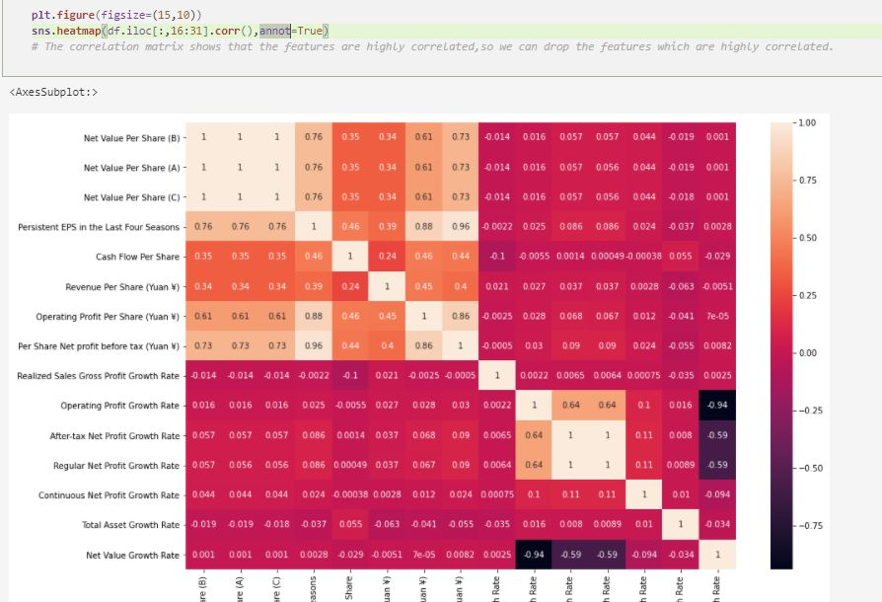

## 2.4 Feature Engineering

Splitting the dataset into training and testing data for model building

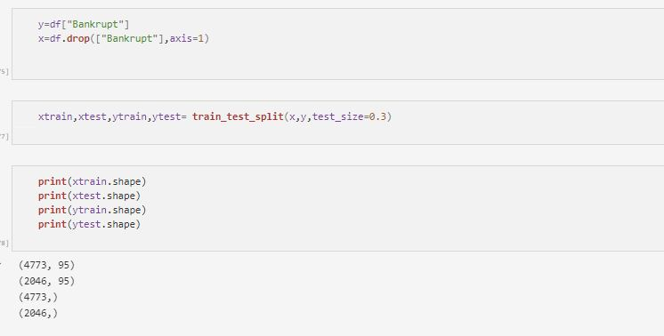

Checking the prevalence rate for the dependent variable.

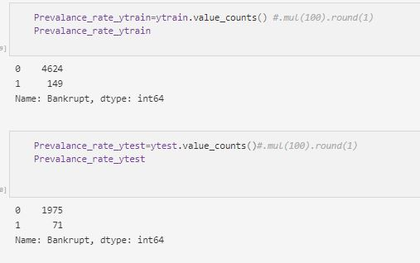

The prevalence rate shows that dataset is imbalanced so we need to perform smote for the dependent variable to make it balanced.

I have performed Oversampling technique- SMOTE for only the training dataset.

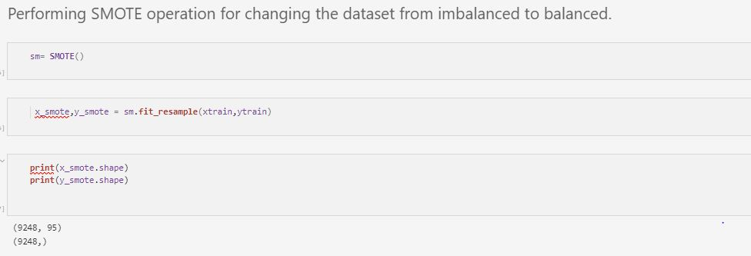

# CHAPTER 3: MODEL BUILDING WITH DATA

Exploratory data analysis and data preprocessing has been done and the data is ready to be fed into the machine learning model so that prediction can be made according to the underlying pattern of the dataset. I have used two classification models for prediction and will choose the best one out of it.

**Models used:**

* **Logistic regression**
* **Random forest**

## 3.1 LOGISTIC REGRESSION MODEL

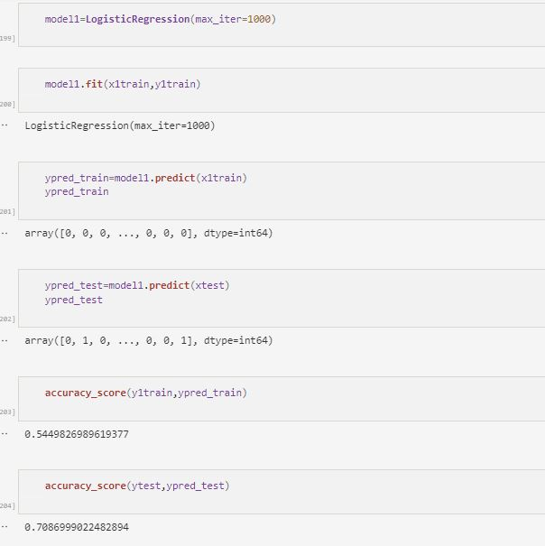

Logistic model is built after performing smote operation which doesn’t provide good accuracy.

3.2 RANDOM FOREST

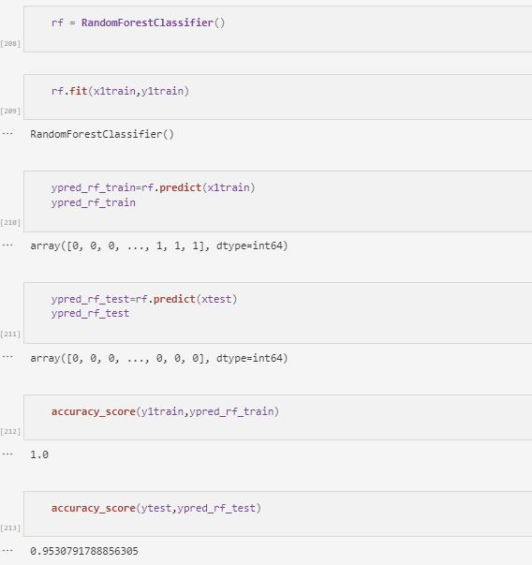

We applied Random Forest on the Training data set to validate if any further improvement of the model can be performed post the logistic regression. In this random forest model I had an over fitting problem. In order to overcome it I have undergone gridsearchcv method.

## 4.2.1 INFRASTRUCTURE CHALLENGES

CHAPTER 4: HYPER PARAMETER TUNING AND RFE

From the above models random forest model gives good accuracy in order to overcome over fitting problem we can use gridsearchcv to find it’s best parameters to reduce it.

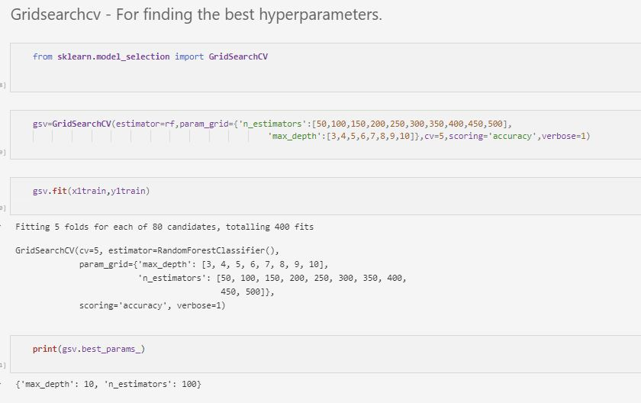

The best parameters for Random forest model is “max\_depth:10 and n\_estimators:100”.

RFE- Recursive Feature Elimination

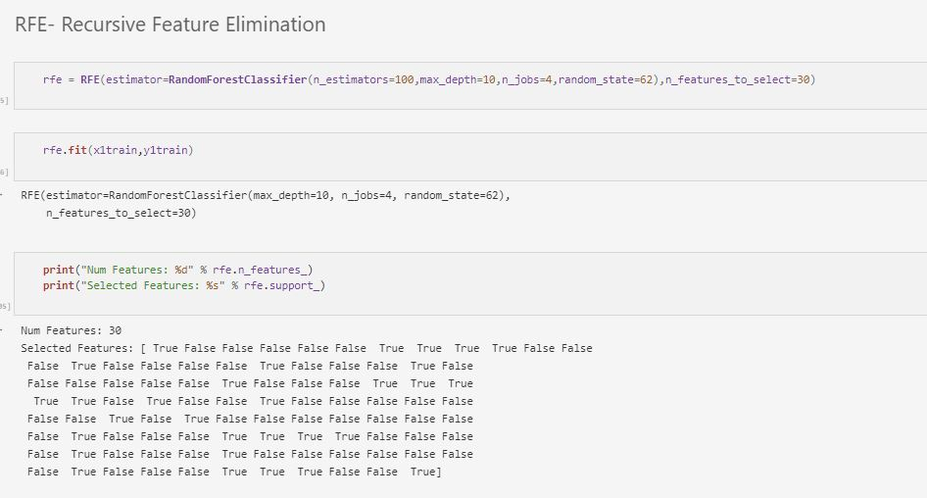

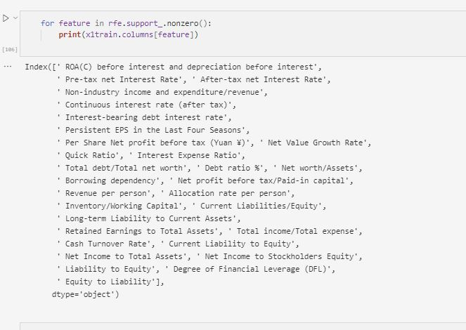

RFE is done to eliminate the features and I have selected the top 30 features that are significantly necessary for predicting the dependent variable. This is done by recursively eliminating the features one by one which are nearly equal to 0.

Hyper tuned model with accuracy

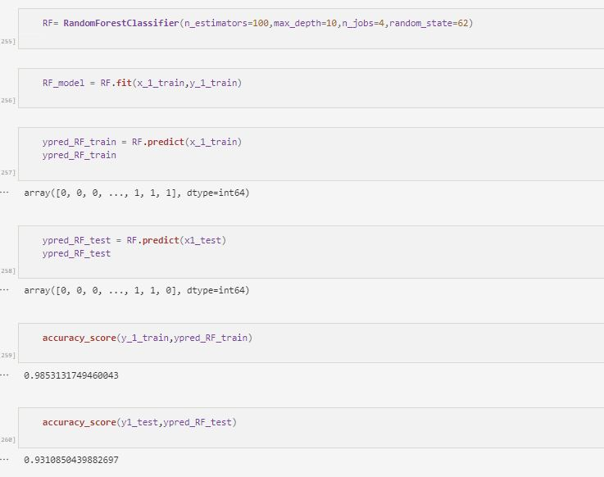

This model provides the good accuracy for training and testing

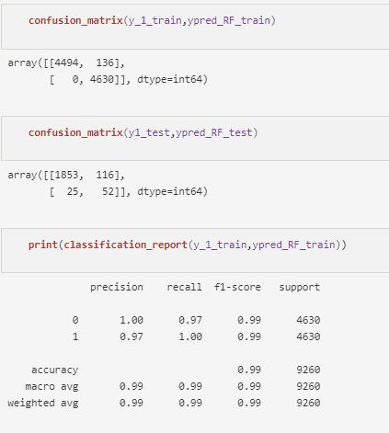

CHAPTER 6: CONCLUSION

The best model for prediction is Random forest for this business problem, Where the model is hyper tuned to get the best results.

The parameter used to adjust the accuracy are “max\_depth:10 and n\_estimators:100”.

Thus the model gave the training accuracy of 98% and testing accuracy of 93%.

Saving the model:

The trained model can be saved and can be reused to predict the result on a new data. The saving of the model is called serialization and while restoring the model is called deserialization, this can be done with the help of pickle library.

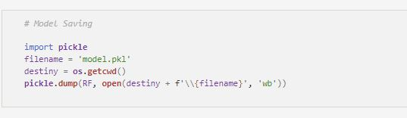

**Pickling**:

The pickle module implements binary protocols for serializing and deserializing a Python object structure. “Pickling” is the process whereby a Python object hierarchy is converted into a byte stream, and “unpickling” is the inverse operation, whereby a byte stream (from a binary file or bytes-like object) is converted back into an object hierarchy. Pickling (and unpickling) is alternatively known as “serialization”, “marshaling,” 1 or “flattening”; however, to avoid confusion, the terms used here are “pickling” and “unpickling”. In real world scenario, the use pickling and unpickling are widespread as they allow us to easily transfer data from one server/system to another and then store it in a file or database.

CHAPTER 6: DEPLOYMENT OF THE MODEL

**Model Deployment:**

Deploying a machine learning model, known as model deployment, simply means to integrate a machine learning model and integrate it into an existing production environment where it can take in an input and return an output. The purpose of deploying your model is so that you can make the predictions from a trained ML model available to others, whether that be users, management, or other systems. Model deployment is closely related to ML systems architecture, which refers to the arrangement and interactions of software components within a system to achieve a predefined goal.

Before we deploy a model, there are a couple of criteria that your machine learning model needs to achieve before it’s ready for deployment:

* **Portability:** this refers to the ability of your software to be transferred from one machine or system to another. A portable model is one with a relatively low response time and one that can be rewritten with minimal effort.
* **Scalability:** this refers to how large your model can scale. A scalable model is one that doesn’t need to be redesigned to maintain its performance

**Real-time model deployment in local server using Streamlit.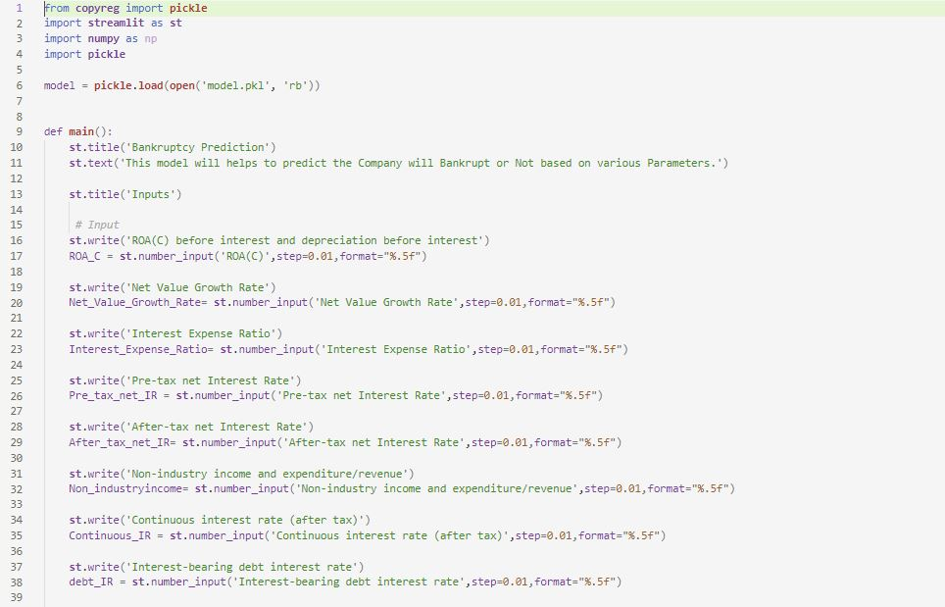**

**Getting the inputs and prediction :**

**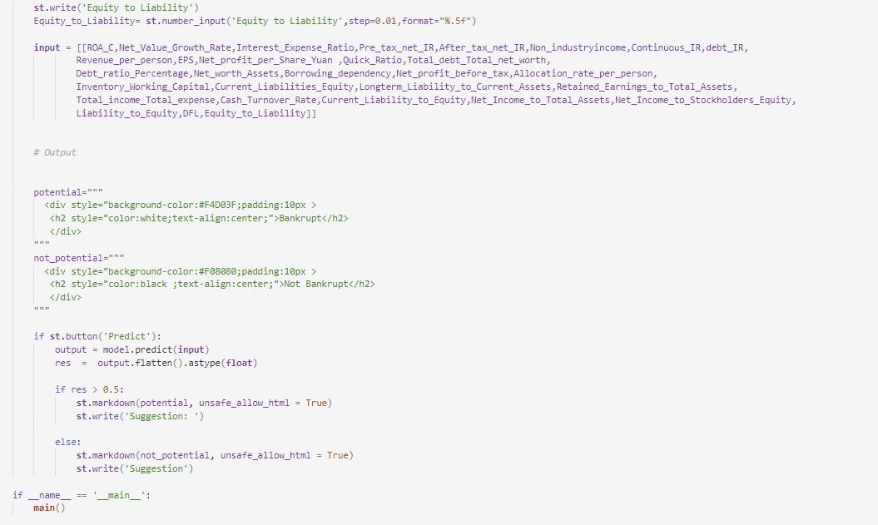**

**Output:**

As a user we are giving the inputs and predicting the output.

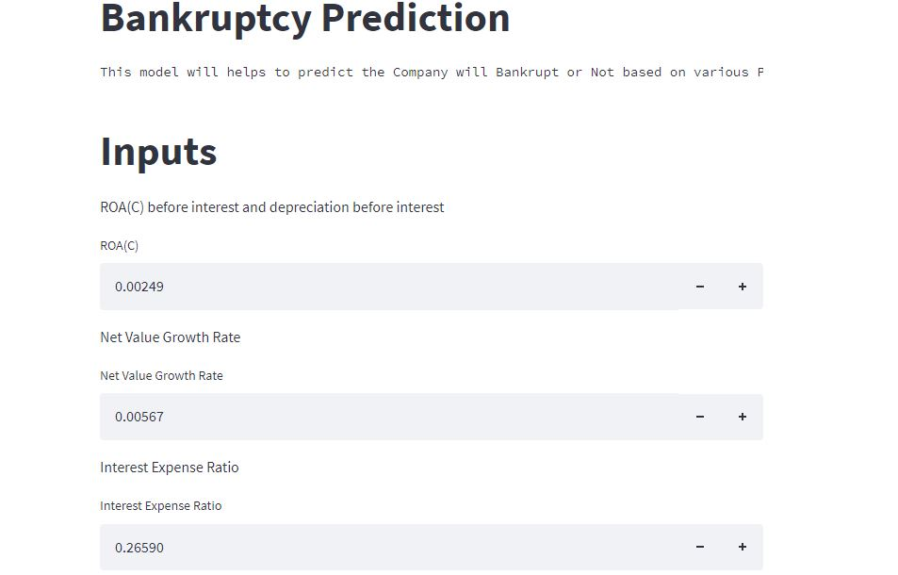

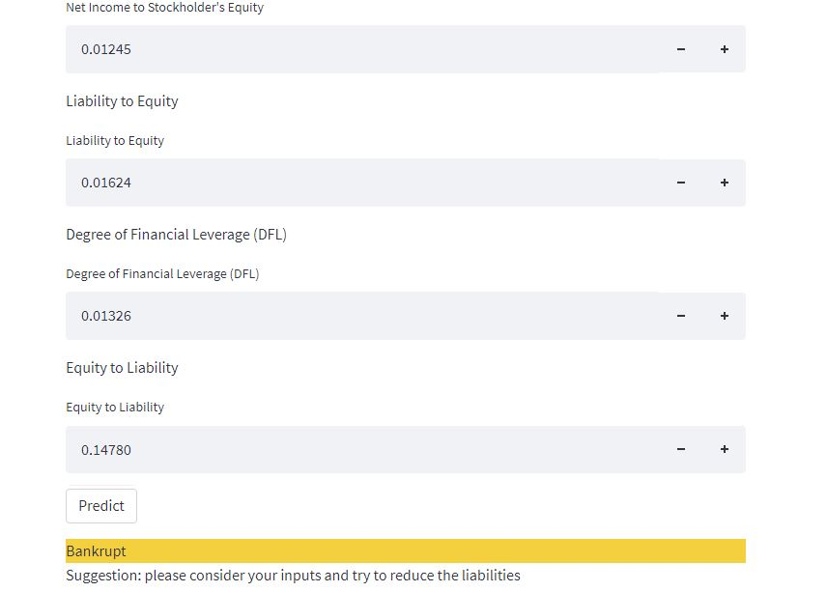

The model is successfully deployed using platform called Streamlit. By giving the input parameters in real time we can earn result and suggestion based on the result what we earned.

CHAPTER 7: REFERENCES

These are the references used while doing this project.

**Links:**

* https://pypi.org/
* https://pandas.pydata.org/docs/
* https://numpy.org/doc/stable/
* https://scikit-learn.org/stable/
* https://streamlit.io/